**appendToFile**:

This command is used to append data into a file. In my example I append data “Hello there” into the file abc.txt which is located at location /user/Hadoop/abc

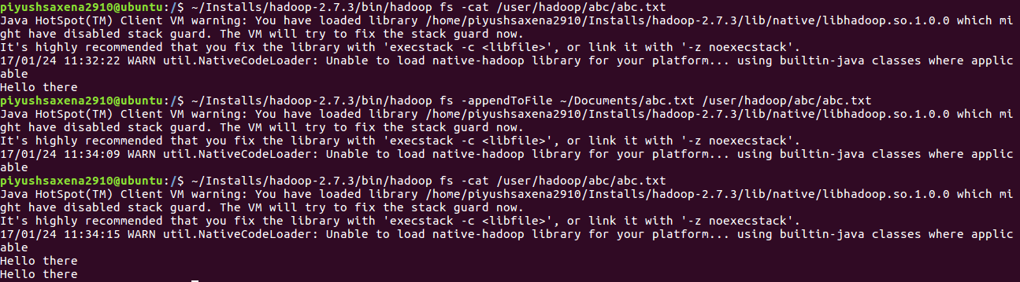

**cat:**

This command is used to print the contents of a file

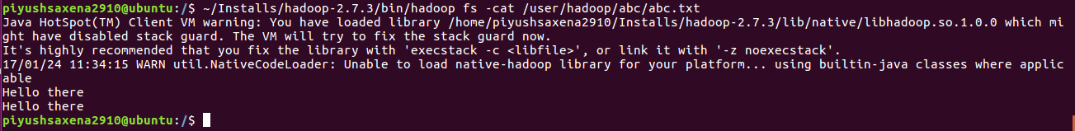

**checksum**:

This command is used to print the checksum information of a file

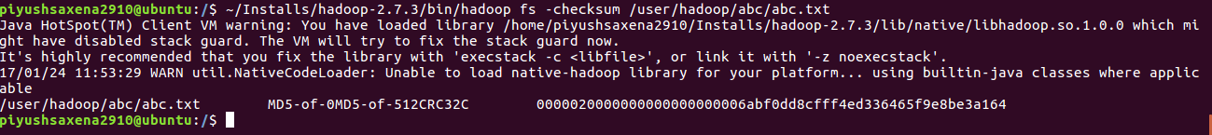

**chgrp**:

This command is used to change the group which can access the file. In my example the file abc.txt is associated with group “supergroup”, after the chgrp command I assign the group as MyOrganization. This is reflected when I run a -lsr command on the file.

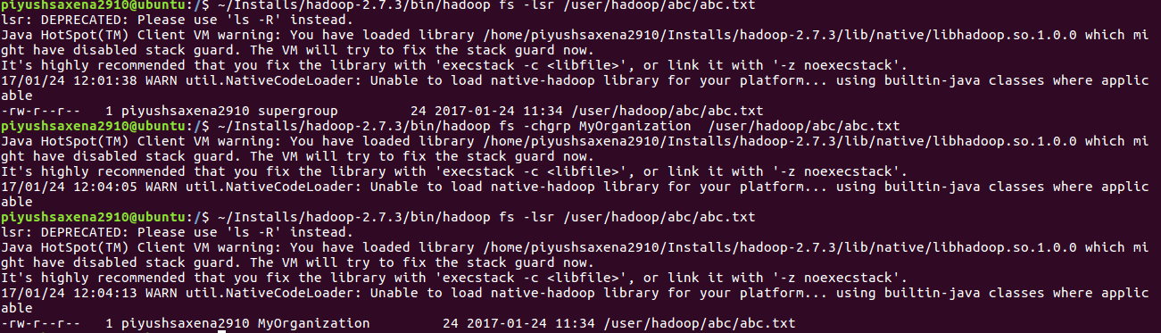

**Chown**:

This command is used to change the owner of a file/folder. In my example I change the file owner from piyushsaxena2910 to saxenapiyush

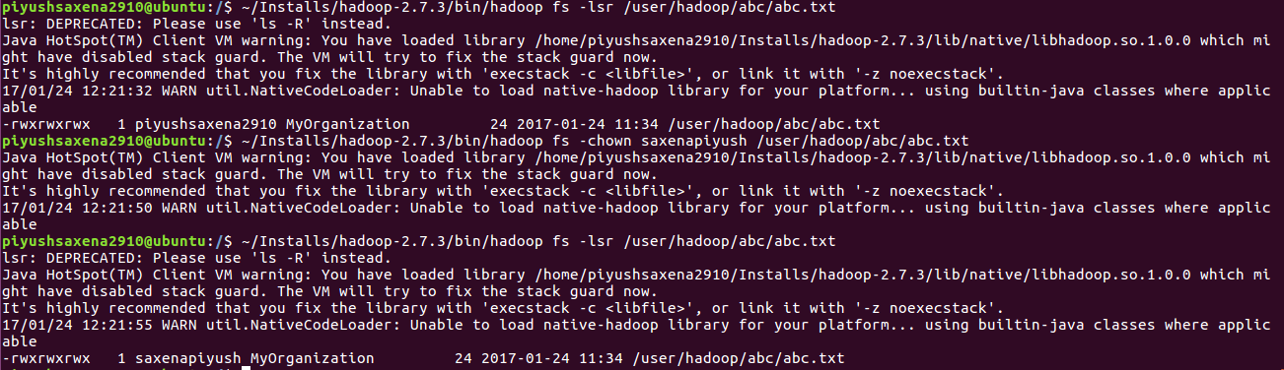

**copyFromFile**:

This command copies a file from the local file system to the hdfs URI

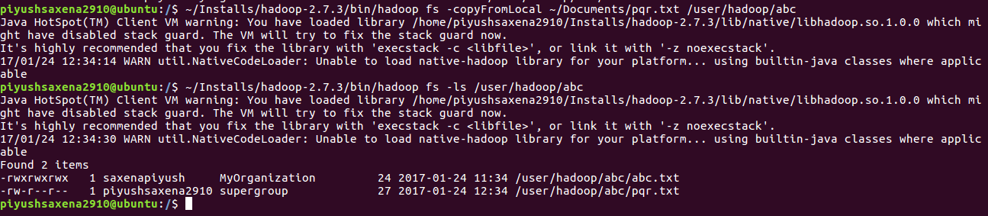

**copyToFile**:

The command copies a file from HDFS URI to a local system

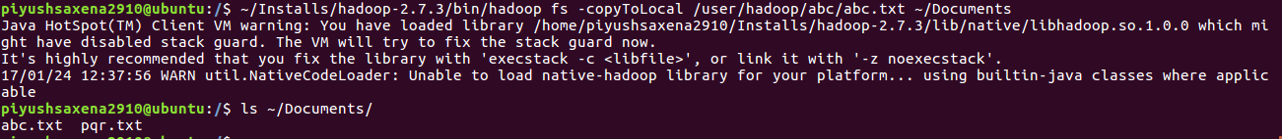

**Count**:

The count command returns the number of directories, files and bytes under the path specified

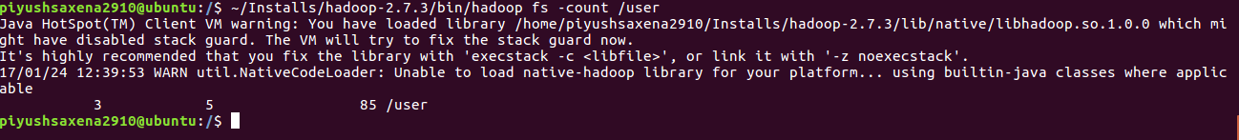

**cp**:

This command copies a file from one location to another within the HDFS

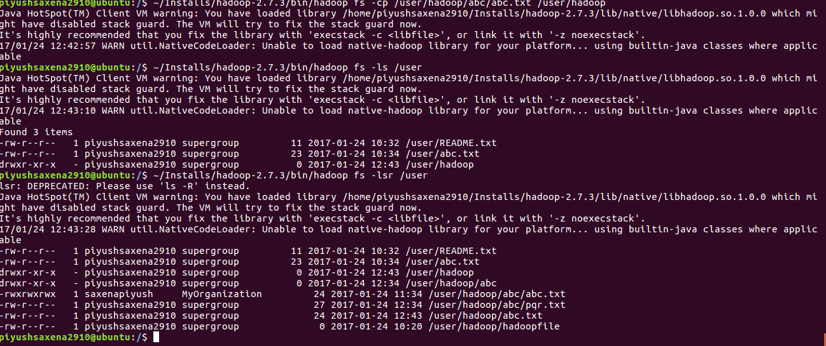

**Chmod**:

This command is used to modify the permissions of a file that can be accessed by the user, group or others. In my case, the permissions with user are only read and write whereas, group and others have read access only. By running the chmod command, I gave read, write and execute permissions to all users.

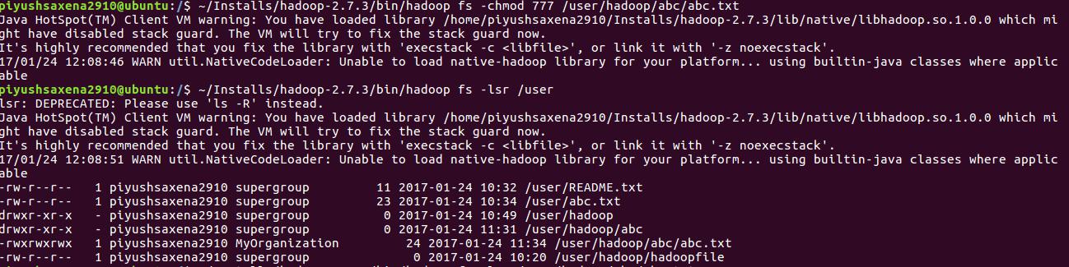

**createSnapshot**:

This command is used to create a snapshot of a file or directory to be used as a recovery mechanism in case of any failures. For a directory to be snapshot-able, we must allow snapshots on that directory:



After this, we can take the snapshot of the directory by giving the directory path and a suitable name for the snapshot.



**deleteSnapshot**:

A snapshot can be deleted from the system by running the deleteSnapshot command.



**Df**:

This command gives the capacity, free space and used space of the filesystem: 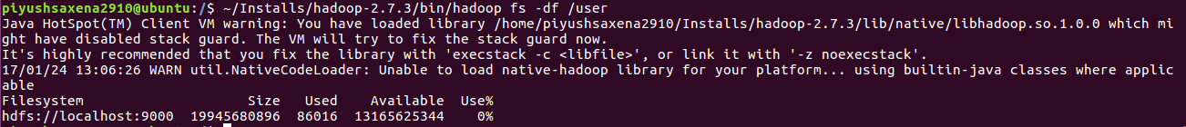

**Du**:

This command gives the size of file and directories contained in the path mentioned

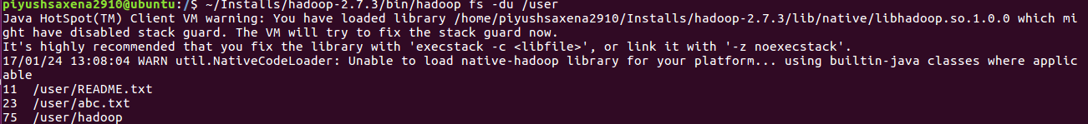

**Dus**:

This command gives the summary of file lengths

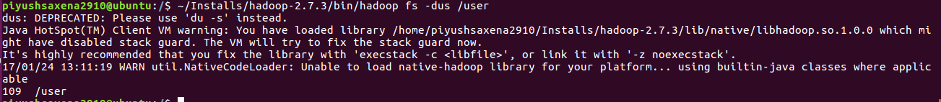

**Expunge**:

This command is used to empty the trash in Hadoop file system. It permanently delete files in checkpoints older than the retention threshold from trash directory, and create new checkpoint.

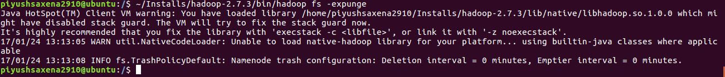

Find:

This command is used to find a particular file in the URI. We can specify the name of files with the -name parameter. Hadoop finds the files with wildcard characters like in the following example

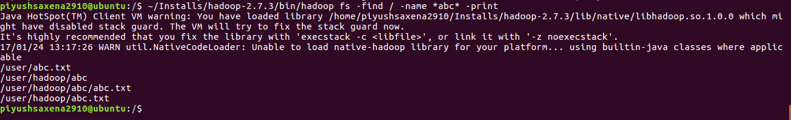

Get:

This command is similar to copyToLocal, it copies a file to the local system

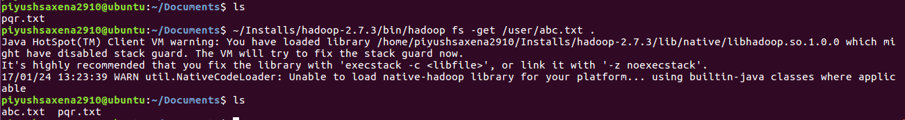

Getfacl:

This command displays the Access Control List of the file or directories.

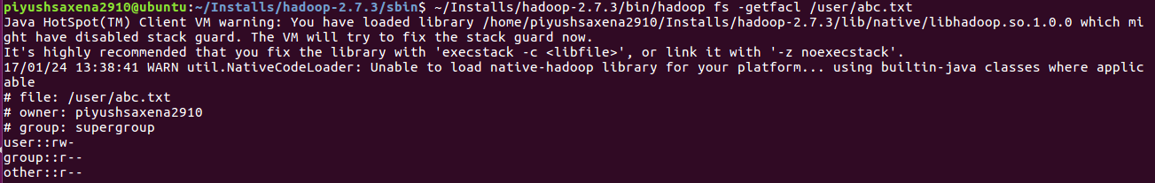

Getfattr:

This command displays the extended attribute names and values

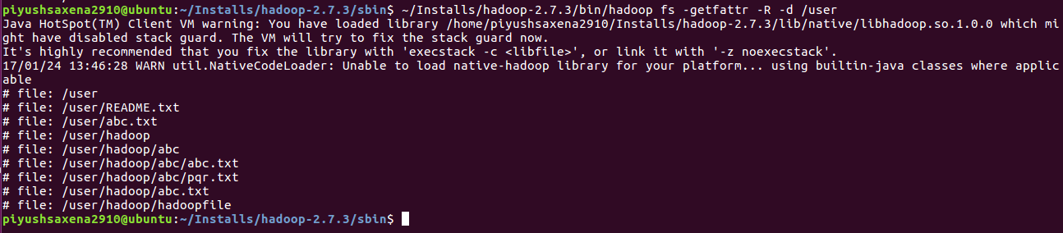

Getmerge:

This command merges inputs from different file from a directory into a local file

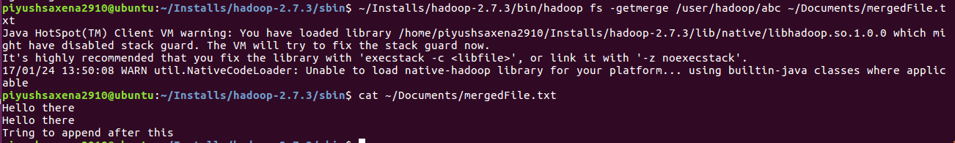

Help:

This command shows the help options. It displays the options of all the commands that can be run for hdfs

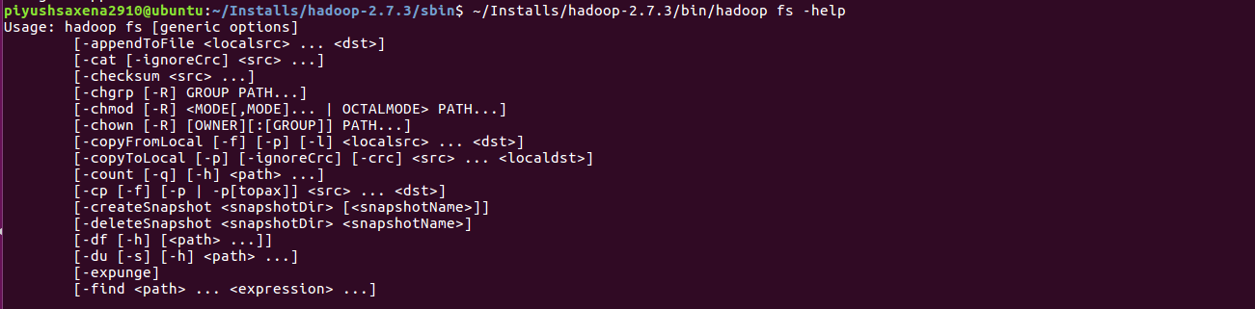

Ls:

Displays all the files present in the path specified

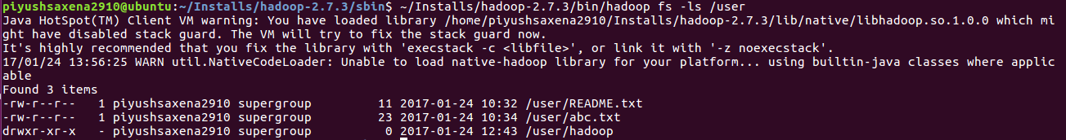

Lsr:

This command shows the files in a recursive manner

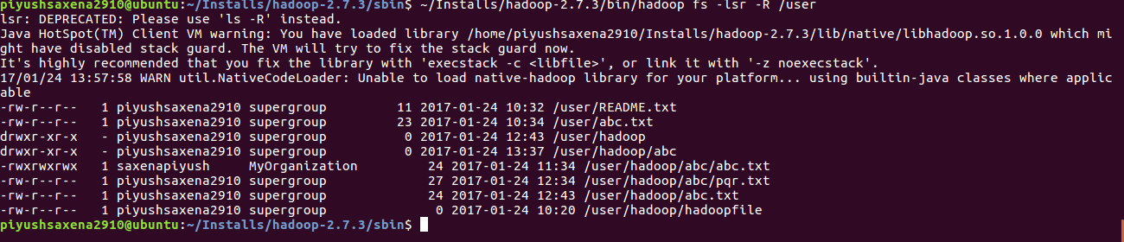

Mkdir:

This command creates a directory under the path specified

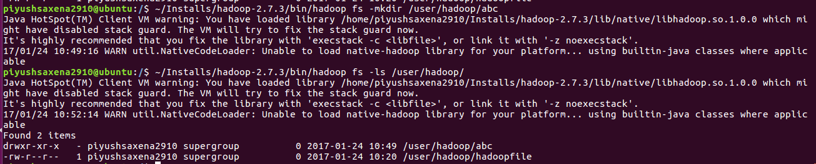

MoveFromLocal:

This command moves a file from the local to the hdfs file system

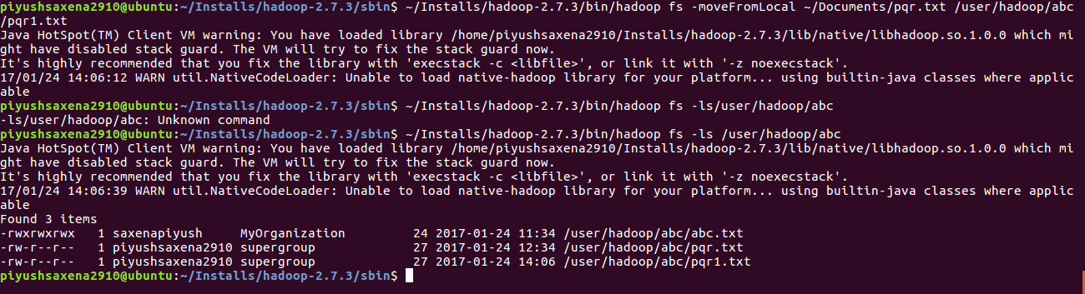

MoveToLocal:

Moves a file to local, shows “Not implemented yet message”



Mv:

This command moves a file from a source to destination

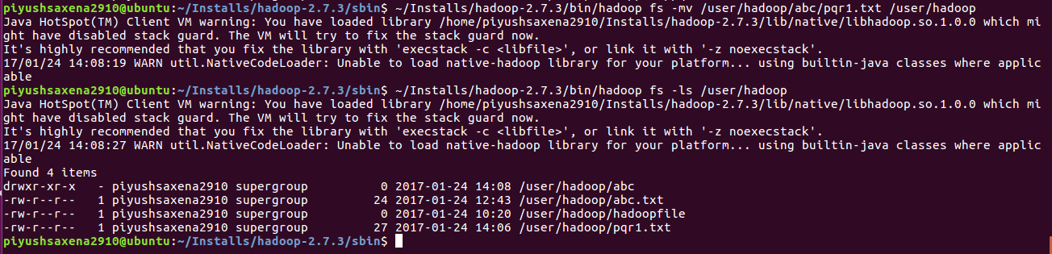

Put:

This command copies one or more files from the local system to the hdfs system

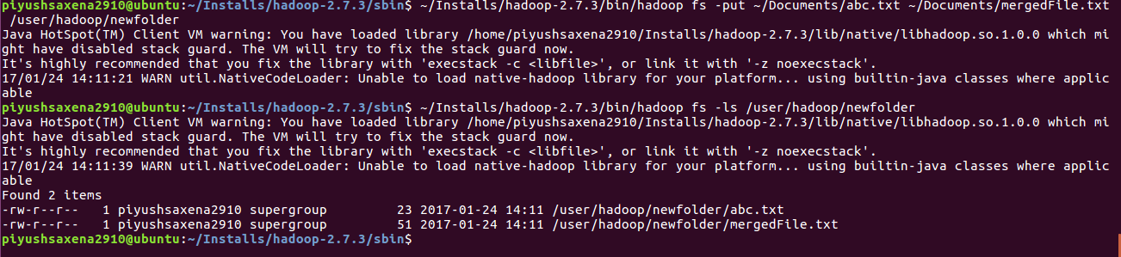

renameSnapshot:

This command renames the snapshot created

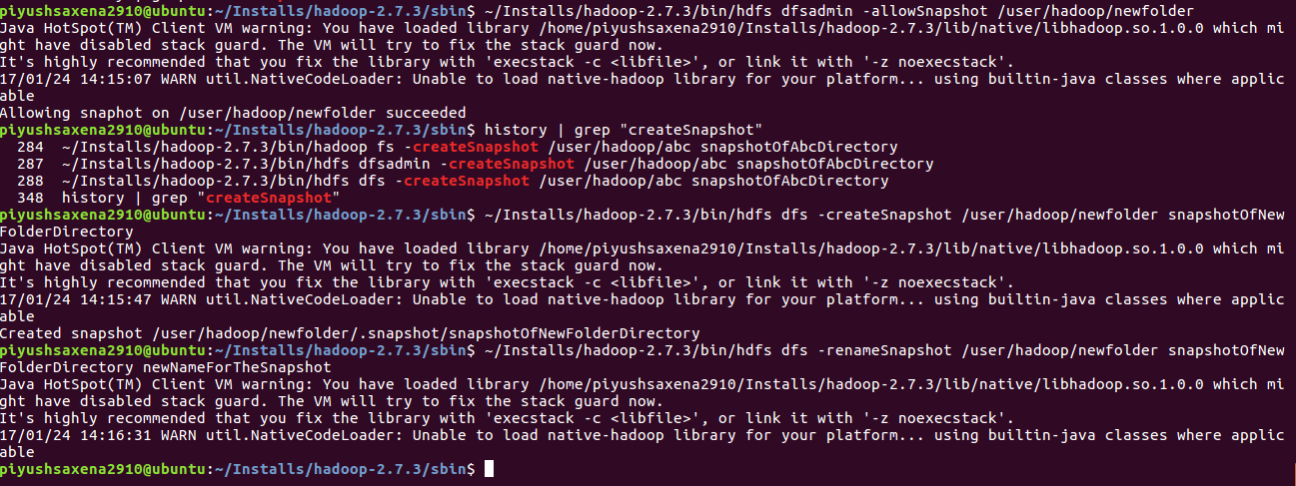

Rm:

This command deletes the specified file

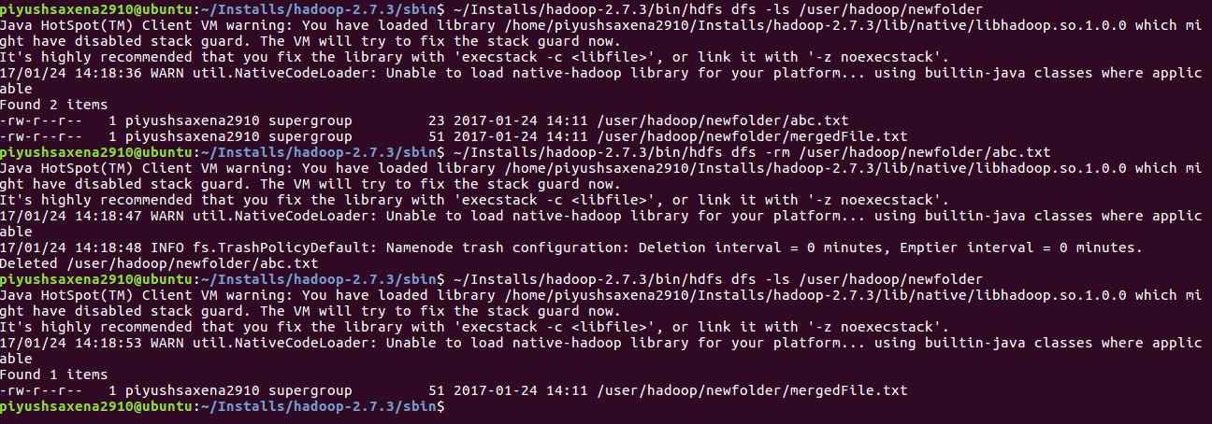

Rmdir:

This command deletes a directory, the directory needs to be empty to run this command. Howeever, we can use the –ignore-fail-on-non-empty if the directory still contains files

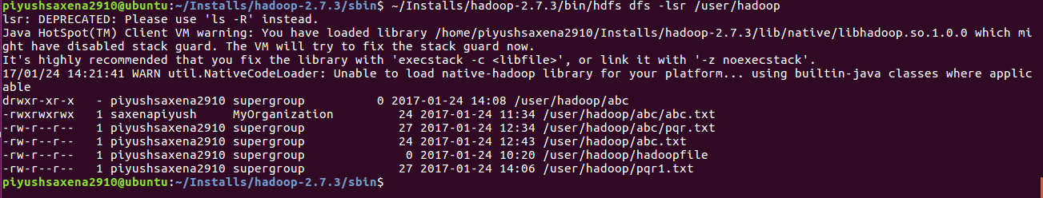

Rmr:

This command is used to recursively delete the contents of a directory

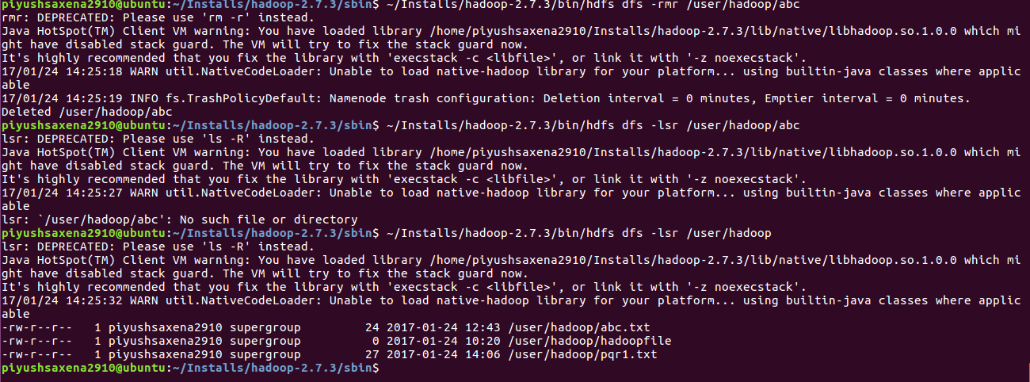

Setfacl:

This command sets the Access Control Lists for the file or directory



Setfattr:

This command sets an extended attribute name and value for a file or directory

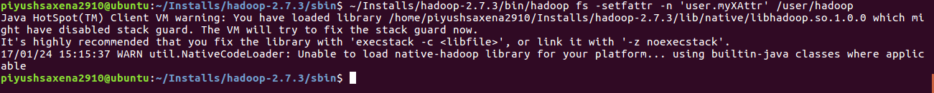

Setrep:

This command changes the replication factor of a file

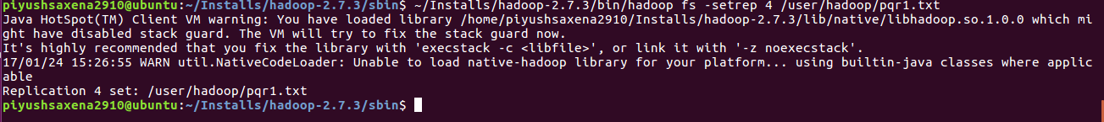

Stat:

This command prints the statistics regarding a file. In this example it prints the owner, group creation time etc of the file.

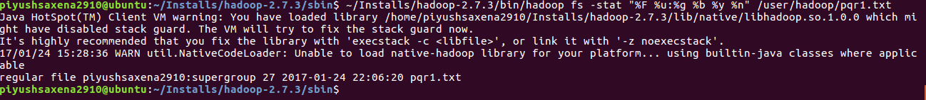

Tail:

This command displays the last kilobyte of a file

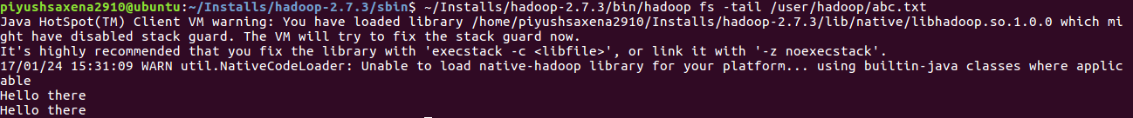

Test:

This command returns results based on the parameters passed, like here when -e is passed, it that the URI passed is a file



Text:

This command prints out the text of the file:

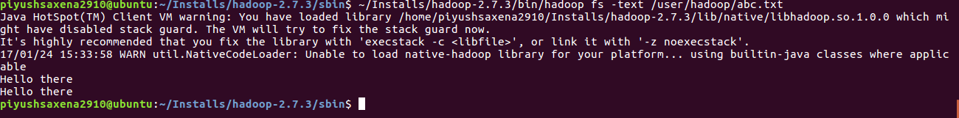

Touchz:

This command creates an empty text file

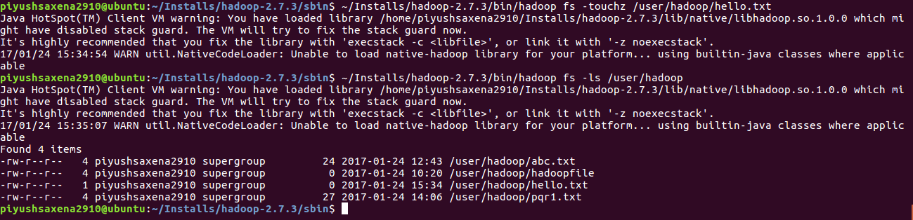

Truncate:

This command truncates the data to a specified length, like in this example 5 characters only remain in the file after the truncation is applied

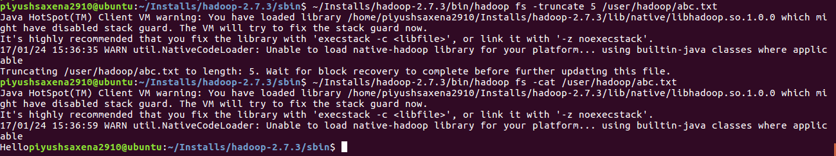

Usage:

This command displays the options that can be used with an hdfs command

